SESSION-1
Defect Management, Bug Life Cycle, Priority & Severity Pending

TASK-1
Pick any mobile app you use daily (like Zomato, Instagram, or Paytm), open its login or signup form, and identify 5 possible defects in the UI or workflow. Write each defect as a clear defect statement.
ANSWER:
App Selected: Zomato
Module: Login/Signup
Possible Defects:
No. | Defect Statement
1 | Login button remains disabled even after entering valid login details.
2 | Password is displayed in plain text instead of being masked.
3 | No proper validation message is displayed when the user leaves a required field empty.
4 | An incorrect password does not show a clear and appropriate error message.
5 | The application accepts an expired OTP during OTP verification.

Conclusion:
These possible defects can affect the usability, validation and security of the login/signup process. Identifying such defects helps testers ensure that users can log in safely and smoothly.

TASK-2
For each defect you found in the previous task, assign a Severity level (Blocker, Critical, Major, Minor, Trivial) and a Priority level (High, Medium, Low). Briefly justify your choice for one defect where severity and priority are different.
Hint: Think about how badly the defect impacts users (severity) versus how quickly it should be fixed (priority).
ANSWER:
App Selected: Zomato
Module: Login/Signup
No. | Defect | Severity | Priority
1 | Login button remains disabled even after entering valid login details. | Major | High
2 | Password is displayed in plain text instead of being masked. | Major | High
3 | No proper validation message is displayed when a required field is empty. | Minor | Medium
4 | Incorrect password does not show a clear error message. | Minor | Medium
5 | Application accepts an expired OTP during OTP verification. | Critical | High

Justification for different Severity & Priority
Defect 3 - Missing validation message
- Severity: Minor → The user can still enter the required information and continue; the main login function is not completely broken.
- Priority: Medium → It should be fixed, but it is not as urgent as a security or login-blocking issue.
Conclusion:
Severity shows how badly the defect affects the application, while Priority shows how urgently the defect should be fixed.

TASK-3
Draw a Bug Life Cycle diagram showing all the main states (New, Assigned, Open, Fixed, Retest, Verified, Closed, Rejected, Deferred, Duplicate, not a Bug) and the transitions between them. You can use pen-paper and upload a photo, or use any diagram tool you like.
ANSWER:
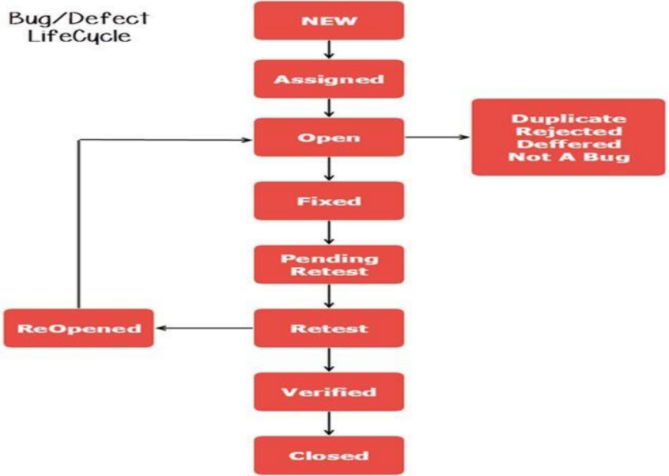

TASK-4
Write a short scenario where a defect in a UPI payment feature (like in PhonePe or Paytm) is found very late—after the app is live. Explain in 4-5 lines how the cost and impact of fixing this defect would be different if it was caught during development instead.
ANSWER:
Suppose a UPI payment defect is found after the app is released, where money is deducted from the user but the payment status is not updated correctly.
After release, fixing it can be costly because it may affect real users, require urgent investigation, refunds and a new release.
If the defect was found during development, it could have been fixed and tested before reaching customers.
Early fixing would require less time and cost and would reduce the impact on users.
Conclusion:
Finding defects early is generally less costly and reduces the risk of affecting real users.

